# BCIA Vancouver Branch 2024 AGM Agenda

5:30 pm Registration, Networking, Refreshments, and Appetizers

5:55 pm Welcoming Remarks by Kathy Ma, P.Ag., Branch President

6:00 pm Keynote Speaker: Dr. David Clements  
Presentation: Invasive Species and Climate Change; Plant Invasions in the Face of Unpredictable Weather and Natural Disasters

6:30 pm Coffee Break/Prize Draw/Mentimeter

7:00 pm AGM

* Call to Order
* Adoption of Agenda
* Adoption of Minutes from 2023 AGM
* Branch Executive Reports
  + President’s Report – Kathy Ma
  + Treasurer’s Report – Adrian On
  + PD Coordinator’s Report – Marika Green
  + Directors’ Report - Noa Bridson, Patricia (Trish) Hanuszak, Kyrie Zhang, Tyler Prentice
  + Articling Coordinator’s Report – Graham Watson
* Articling Presentations
* Election of 2025 Branch Executive Members
* Provincial/Central Updates
  + Councillors’ Report – Warren Mills
  + BCIA CEO and Registrar Jennifer Lawrence
* Awards and Acknowledgements
* PAg and TAg Oath Reading
* New Business
* Final Gift Draws

9:00 pm Motion to Adjourn

9:05 pm New Branch Executive - Meet with incoming Present, Carson Li

9:15 pm Aggie Drinks (Tap & Barrel, downstairs)

# Vancouver Branch

President’s Report - **2024**

**2024 President:** Kathy Ma, P.Ag.

The Vancouver BCIA Branch had another successful year creating opportunities for Registrants to expand their professional knowledge, increase their professional network, and help articling Agrologists achieve professional status. With the full team of directors on the executive this year, several PD events were held both virtually and in-person, providing registrants a variety of opportunities to attend and gain knowledge, while networking with fellow agrologists.

Noa Bridson, Branch Director, helped to host an online QGIS Webinar Series, instructed by Dr. Paul Pickell over five weeks, covering mapping topics including Essential Mapping, Suitability, Hydrology, Imagery, and LiDAR for agrology and other environmental management purposes. This immensely popular event series was well attended with interest in repeating for future years. Noa also helped to organize a Joint Trivia & Networking event with PRSSS in order to raise awareness with students and other potential agrology practitioners.

Kyrie Zhang, Branch Director, organized a well attended lunch and learn webinar on Cannabis Cultivation and Plant Science, an impressive feat as this was done across several timezones in order to accommodate our speaker Dr. Jonatan Montpetit (Master Grower, Sr. Director of Plant Science, Organigram), joining us from New Brunswick.

Trish Hanuszak, Branch Director, organized multiple in-person events: 1) a very popular tour of the Noon's Creek Hatchery in Port Moody, where all registered participants attended despite the atmospheric river and extremely heavy rains; and 2) a great behind the scenes look at Barnside Brewing in Delta, where participants were sample to see the on-site farm and try locally farmed food and beverages.

Marika Green, PD Coordinator, organized a watershed tour of the Coquitlam watershed, well attended by members on a beautiful sunny day. The Annual full-day PD event is collaboratively hosted by both the Vancouver and Fraser Valley branches on alternating years. In 2024, this joint event was hosted by the Fraser Valley branch in November, on the topic “Resiliency in Response to Climate-Driven Extremes.”

Branch Directors Tyler Prentice and Kate Schendel put in time and efforts in researching some great event ideas, which will help with planning in future years. They also provided a supportive role to the team and worked to be a valuable sounding board during the planning process.

Deb Bryant, Secretary, took helpful monthly meeting minutes and helped to keep us organized and accountable with our action items.

Adrian On, Treasurer, ensured that our events were able to stay within our budget and collaborated with fellow board members in the event planning process.

Graham Watson, Articling Coordinator, graduated many articling registrants to full Professional status, organized volunteer opportunities, introductions and oath readings, and always made himself available to answer any questions articling registrants have had.

Carson Li, President-Elect, supported the team throughout the year, including being available to help with PD events and helping organize the Annual General Meeting (AGM) this year.

The District Board members Warren Mills, Yasemin Parkinson and Kirk Phair represent District 3 on the board. Warren regularly kept us informed of board updates and was always available to provide valuable feedback and support to the executive.

I’m very grateful for all the volunteer time and efforts contributed in 2024. Thank you to the 2024 Vancouver Branch Executive!

As my year as the President comes to an end and 2025 begins, I am very pleased to leave the Branch Executive in the hands of our incoming President, Carson Li. Carson will bring a fresh perspective, great organization, and many interesting PD events to support our Branch registrants.

Prepared by:

Kathy Ma, P.Ag.

# Vancouver Branch

Treasurer’s Report - **2024**

**2024 Treasurer:** Adrian On, P.Ag.

We will be entering 2025 with close to $5,000 to carry forward into the new budget. We expect costs for putting on events to increase, but we will continue to subsidize students and members as much as possible while considering the costs of hosting the joint PD event this year with the Fraser Valley.

**2024 Financials:**

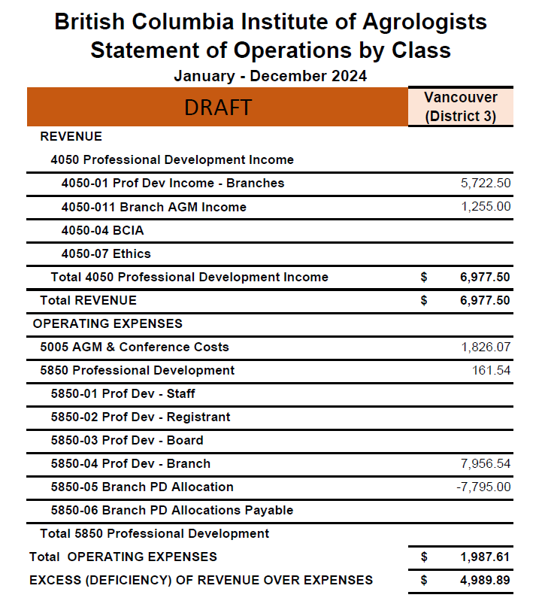

This is our proposed 2025 budget, with no costs confirmed besides the catering fee for the 2025 AGM. We have the budget to put on 6 PD events throughout the year, and a larger budget allocated to the joint PD event with the Fraser Valley.

**Estimated 2025 Budget:**

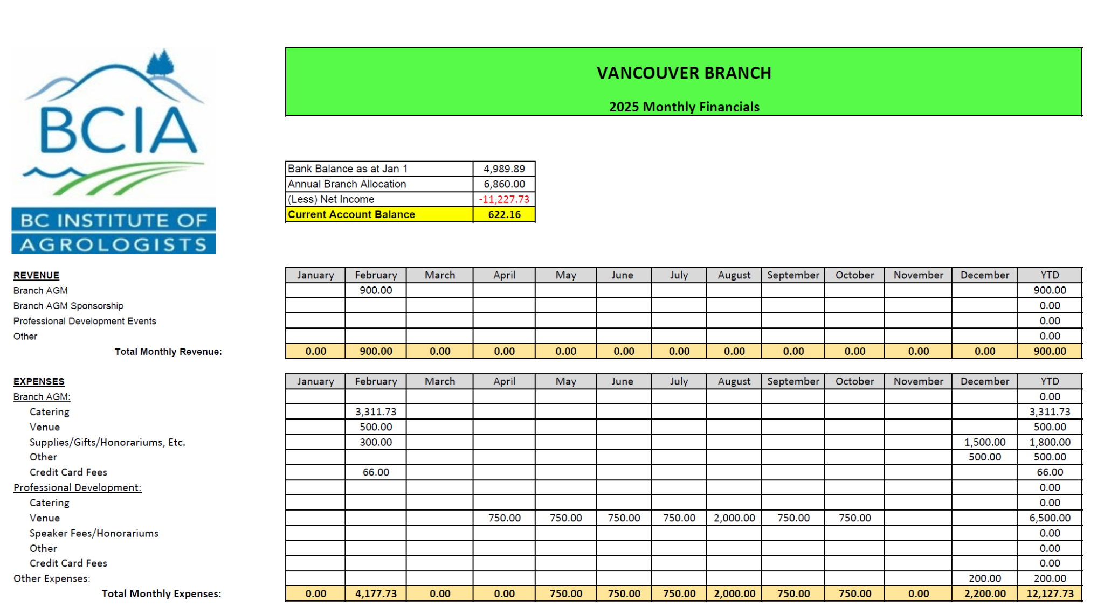

Prepared by:

Adrian On, P.Ag.

# Vancouver Branch

Articling Program Coordinator’s Report - **2024**

**2024 Articling Coordinator:** Graham Watson, P.Ag.

I have been pleased to continue my role as Articling Coordinator for a third year for the Vancouver Branch Executive Committee between the 2024 and 2025 AGMs. The past three years in this role have been greatly rewarding providing guidance to registrants through their articling periods.

Since the 2023 AGM, BCIA Vancouver Branch has registered:

* 33 new Articling Agrologists (A.Ag)
* 9 new Articling Technical Agrologist (A.T.Ag.)
* 14 new student members

Congratulations to the 26 registrants who have completed their articling requirements in 2024, and have now gained the status of Professional and Technical Agrologists! Well done all.

* Alexander Allsopp, PAg
* Andre Antonio, PAg
* Franco Lopez Campomanes, PAg
* Andrew Chan, PAg
* Crystal Chan, PAg
* Karina Ernst, PAg
* Carol Fu, PAg
* Daniel Gorton, PAg
* Ryder Hoy, PAg
* Erin Jankovich, TAg
* Elizabeth Jeffs, PAg
* Alyssa Johnston, PAg
* Sianna Kennedy, TAg
* Heidi Lundstrum, TAg
* Diana Nowak, PAg
* Katelyn Ocampo, PAg
* Connie Olsen, PAg
* Emily Peer-Groves, PAg
* Alia Reeves, PAg
* Danielle Samels, PAg
* Eleanor Stewart, TAg
* Darren Stott, PAg
* Daniel Tan, PAg
* Tishtaar Titina, PAg
* Mabel Tsang, PAg
* Breanna Uphill, TAg
* Tamara Walton, TAg
* Shirley Zhu, PAg

As of January 13, 2025 there are 438 total Vancouver branch members:

* 246 active P.Ag.
* 10 active T.Ag.
* 77 active A.Ag.
* 16 active A.T.Ag.
* 0 L.L.Ag.
* 21 On Leave (all categories)
* 29 Retired
* 39 Student members.

The following registrants received 25-year service recognitions for 2024:

* Oliver Busy, PAg
* Paul van Westendorp, PAg
* Cindy Ott, PAg
* Nicole Sillett, PAg

On behalf of the Branch Executive, I would like to thank all members who have volunteered as mentors. If you are interested in becoming a mentor, please reach out! The mentoring program enhances professionalism within the organization, and provides articling mentees an opportunity to build their networks and learn more about the profession of Agrology.

Thanks for another great year!

Prepared by:

Graham Watson, P.Ag.

# Vancouver Branch

Professional Development Coordinator’s Report - **2024**

**2024 PD Coordinator:** Marika Green, P.Ag.

The Professional Development Event is jointly hosted by the Vancouver and Fraser Valley branches on alternating years. For 2024, the Fraser Valley branch hosted the event.

On November 2, 2024 the joint PD event was held at the Signature Sandman Hotel in Langley BC. The event focused on how climate change has been affecting the agricultural sector and how we are responding to these new climate extremes. Some of the topics relating to climate change impacts on the agricultural sector included drought, intense rainfall, floods, storms, landslides and the impacts they have on the agriculture sector.

Speakers to this event included:

* Dr. Elizaveta Malinina - Environment and Climate Change Canada
* Ted van Der Gulik - Partnership for Water Sustainability in BC
* Professor Diane Dupont - Brock University, Department of Economics and Environmental Sustainability Research Centre
* Assistant Professor Chris Bodnar - University of the Fraser Valley, Agriculture
* Mark Raymond - Ministry of Agriculture and Food, Agriculture Resource Division
* Ken Nickel - British Columbia Agriculture Council

Prepared by:

Marika Green, P.Ag

# Vancouver Branch

Director’s Report - **2024**

**2024 Directors:** Noa Bridson, A.Ag., Patricia Hanuszak, P.Ag., Kyrie Zhang, P.Ag, Tyler Prentice, P.Ag., Kate Schendel, P.Ag.

This year the Vancouver Branch organized:

**QGIS Webinar Series - Essential Mapping, Suitability, Hydrology, Imagery, LiDAR**

The Essential QGIS for Agrologists webinar series took place over five week from May 13 to June 26, taught by Dr. Pickell, provided participants with an introduction to spatial data, analysis and visualization using QGIS software. Participants gained hands-on experience through five interactive workshops, applying essential skills to real-world case studies relevant to agrology in British Columbia. The series was a resounding success, leaving attendees equipped and excited to incorporate QGIS into their professional work!

**Lunch & Learn Webinar: Cannabis Cultivation and Plant Science**

On November 7, 2024, we were pleased to have Dr. Jonatan Montpetit (Master Grower, Sr. Director of Plant Science, Organigram) to give a Lunch & Learn webinar on cannabis cultivation and plant science. This online webinar had about 20 participants. Jonatan had a thorough knowledge on the cannabis cultivation, product, and plant science; and certain roadblocks the industry is facing. It was a great opportunity to learn more about the cannabis industry.

**Joint Trivia & Networking event with PRSSS**

The Soil Trivia and Networking event on June 20, 2024 attracted a fantastic turnout of soil enthusiasts from diverse backgrounds, all united by their passion for soil science. Attendees tested their knowledge of soil health and its indicators as teams competed for exciting PRSSS merchandise. It was a rewarding evening filled with networking opportunities and insightful discussions, bringing together professionals from across various sectors of agrology

**Metro Vancouver Watershed (Coquitlam)**

On July 7, 2024, the Vancouver and Fraser Valley Branches took a tour of the Coquitlam Watershed. Attendees got out in the sunshine and learned about the history of our drinking water in the Lower Mainland, how our water is treated and ecosystem health.

**Port Moody Ecological Society Noons Creek Hatchery Tour (Port Moody)**

On October 19, the Port Moody Ecological Society hosted a tour and educational event at Noons Creek Hatchery during Coho salmon spawning season. We learned about the process of spawning, raising, and releasing salmon, as well as the broader impacts hatchery based production has on our environment. Attendees: 25

**Farm-to-Glass Agrology: An In-Depth Tour of Barnside Brewery (Ladner)**

On November 17, Barnside Brewing, one of BC’s few farm-based breweries hosted a tour of their facility and farm. Attendees got to explore the essential role of soil health in crop production for brewing ingredients, the techniques of hop cultivation, and the processes behind barley growth, malting, and brewing, as well as networking with other branch members over locally produced snacks and Barnside brews.

Attendees: 25

Prepared by:

Noa Bridson, A.Ag., Patricia Hanuszak, P.Ag., Kyrie Zhang, P.Ag, and Tyler Prentice, P.Ag.